**Blinkit Analysis**

* See all the data imported:

SELECT * FROM blinkit_data

* **DATA CLEANING:**

The presence of multiple variations of the same category (e.g., LF, low fat vs. Low Fat) can cause issues in reporting, aggregations, and filtering. By standardizing these values, we improve data quality.

UPDATE blinkit_data

SET Item_Fat_Content =

CASE

WHEN Item_Fat_Content IN ('LF', 'low fat') THEN 'Low Fat'

WHEN Item_Fat_Content = 'reg' THEN 'Regular'

ELSE Item_Fat_Content

END;

SELECT DISTINCT Item_Fat_Content FROM blinkit_data;

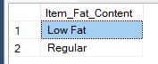

**A. KPI’s**

**1. TOTAL SALES:**

SELECT CAST(SUM(Total_Sales) / 1000000.0 AS DECIMAL(10,2)) AS Total_Sales_Million

FROM blinkit_data;

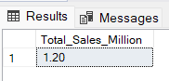

**2. AVERAGE SALES**

SELECT CAST(AVG(Total_Sales) AS INT) AS Avg_Sales

FROM blinkit_data;

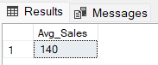

**3. NO OF ITEMS**

SELECT COUNT(*) AS No_of_Orders

FROM blinkit_data;

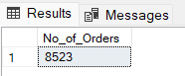

**4. AVG RATING**

SELECT CAST(AVG(Rating) AS DECIMAL(10,1)) AS Avg_Rating

FROM blinkit_data;

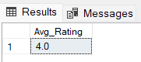

**B. Total Sales by Fat Content:**

SELECT Item_Fat_Content, CAST(SUM(Total_Sales) AS DECIMAL(10,2)) AS Total_Sales

FROM blinkit_data

GROUP BY Item_Fat_Content

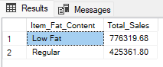

**C. Total Sales by Item Type**

SELECT Item_Type, CAST(SUM(Total_Sales) AS DECIMAL(10,2)) AS Total_Sales

FROM blinkit_data

GROUP BY Item_Type

ORDER BY Total_Sales DESC

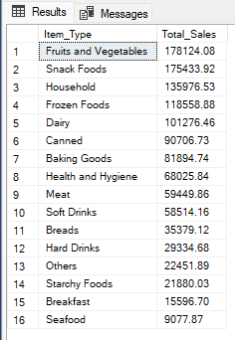

**D. Fat Content by Outlet for Total Sales**

SELECT Outlet_Location_Type,

ISNULL([Low Fat], 0) AS Low_Fat,

ISNULL([Regular], 0) AS Regular

FROM

(

SELECT Outlet_Location_Type, Item_Fat_Content,

CAST(SUM(Total_Sales) AS DECIMAL(10,2)) AS Total_Sales

FROM blinkit_data

GROUP BY Outlet_Location_Type, Item_Fat_Content

) AS SourceTable

PIVOT

(

SUM(Total_Sales)

FOR Item_Fat_Content IN ([Low Fat], [Regular])

) AS PivotTable

ORDER BY Outlet_Location_Type;

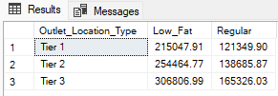

**E. Total Sales by Outlet Establishment**

SELECT Outlet_Establishment_Year, CAST(SUM(Total_Sales) AS DECIMAL(10,2)) AS Total_Sales

FROM blinkit_data

GROUP BY Outlet_Establishment_Year

ORDER BY Outlet_Establishment_Year

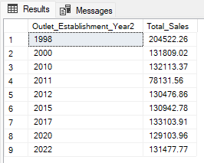

**F. Percentage of Sales by Outlet Size**

SELECT

Outlet_Size,

CAST(SUM(Total_Sales) AS DECIMAL(10,2)) AS Total_Sales,

CAST((SUM(Total_Sales) * 100.0 / SUM(SUM(Total_Sales)) OVER()) AS DECIMAL(10,2)) AS Sales_Percentage

FROM blinkit_data

GROUP BY Outlet_Size

ORDER BY Total_Sales DESC;

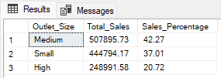

**G. Sales by Outlet Location**

SELECT Outlet_Location_Type, CAST(SUM(Total_Sales) AS DECIMAL(10,2)) AS Total_Sales

FROM blinkit_data

GROUP BY Outlet_Location_Type

ORDER BY Total_Sales DESC

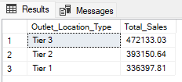

**H. All Metrics by Outlet Type:**

SELECT Outlet_Type,

CAST(SUM(Total_Sales) AS DECIMAL(10,2)) AS Total_Sales,

CAST(AVG(Total_Sales) AS DECIMAL(10,0)) AS Avg_Sales,

COUNT(*) AS No_Of_Items,

CAST(AVG(Rating) AS DECIMAL(10,2)) AS Avg_Rating,

CAST(AVG(Item_Visibility) AS DECIMAL(10,2)) AS Item_Visibility

FROM blinkit_data

GROUP BY Outlet_Type

ORDER BY Total_Sales DESC

